📊 Apple iTunes Music Store – Insights Report

Labmentrix Final Project Submission
Your Name: Gangarapu Datha Naga Sai
Tools Used: MySQL, Power BI

📌 Project Overview: -
This project analyzes the Apple iTunes Music Store database using SQL for data extraction and Power BI for visualization. The objective is to derive business insights related to revenue, customer behavior, genre trends, and country-wise performance.
It makes your report more professional.

Executive Summary:-
This project analyzes the Apple iTunes Music Store database using SQL and Power BI to identify key business insights.

The analysis covers customer behavior, revenue performance, genre popularity, top-performing artists, and country-level sales trends.

Key findings indicate that:
• USA is the highest revenue-generating country
• Rock is the most popular genre globally
• High-value customers significantly contribute to revenue
• Video media types are priced higher than audio formats

The dashboard provides a visual overview of revenue distribution, customer count, invoice trends, and genre performance.
Q1. Senior Most Employee
The senior-most employee based on job level holds the highest position in the organization.
This shows the leadership hierarchy within the company.
Insight: The company has a structured management level, ensuring operational control.

Q2. Countries With Most Invoices
USA generated 131 invoices, the highest among all countries, followed by Canada with 76 invoices.
Insight: North America is the strongest market for iTunes. Marketing efforts should continue focusing there.

Q3. Top 3 Invoice Totals
The highest individual invoice totals indicate premium or bulk purchases.
Insight: Some customers make high-value purchases. The company can target similar customers with premium bundles.

Q4. City With Highest Revenue
The city generating the highest total revenue should be prioritized for events.
Insight: Hosting promotional events in this city may maximize returns.

Q5. Best Customer
The customer with the highest spending contributes significantly to revenue.
Insight: Loyalty programs should target high-spending customers.

Q6. Rock Music Listeners
Rock music has a large and dedicated customer base.
Insight: Rock remains a dominant genre and should receive strong promotional focus.
Q7. Top 10 Rock Artists
Artists like Queen and Jimi Hendrix have the highest number of rock tracks purchased.
Insight: Classic rock artists generate strong demand.

Q8. Tracks Longer Than Average
Some songs are significantly longer than average duration.
Insight: Customers also enjoy extended-format music.

Q9. Customer Spending on Artists
Certain customers spend heavily on specific artists.
Insight: Artist-specific campaigns can increase targeted revenue.

Q10. Most Popular Genre by Country
Rock dominates in most countries.
Insight: Rock is globally popular and should remain a priority genre.

Q11. Top Customer by Country
Each country has a key high-value customer.
Insight: Regional customer loyalty programs can improve retention.

Q12. Most Popular Artists
Queen is the most purchased artist overall.
Insight: Legendary artists continue to drive strong sales.

Q13. Most Popular Song
“War Pigs” is the most purchased song.
Insight: Certain iconic songs consistently perform well.
Q14. Average Prices by Media Type
Video files are priced higher than audio files.
Insight: Customers are willing to pay premium prices for video content.

Q15. Most Popular Countries for Purchases
USA leads total purchases, followed by Canada and Brazil.
Insight: International expansion strategies should consider these markets.

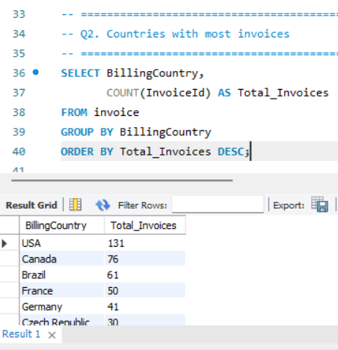

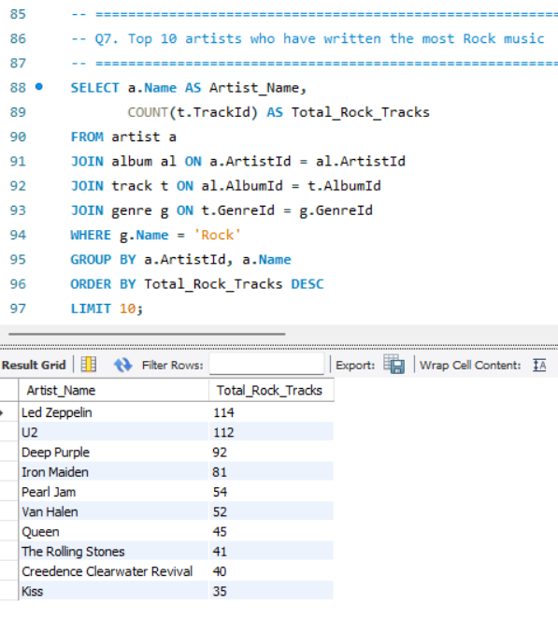
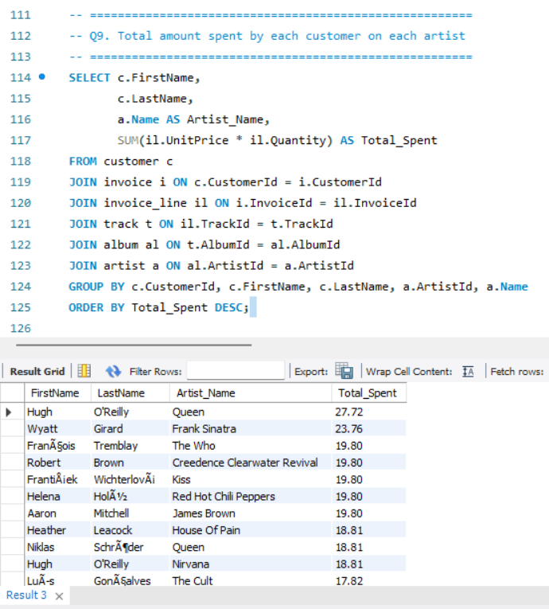
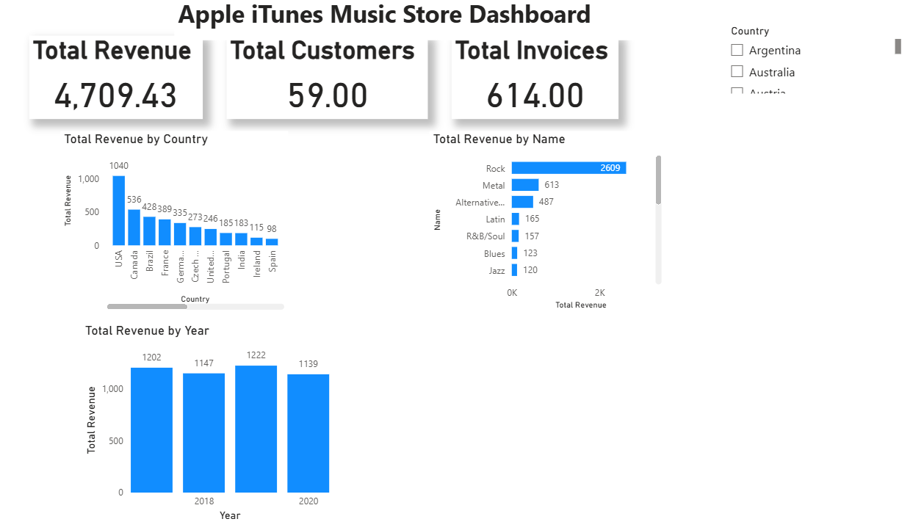

Project Repository
Complete project files including SQL scripts and Power BI dashboard are available at:

Final Conclusion
The Apple iTunes Music Store analysis reveals that North America is the strongest market, with Rock music dominating global preferences. High-value customers and premium media formats contribute significantly to total revenue. Strategic focus on top-performing countries, genres, and artists can help maximize future growth and customer retention.

